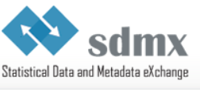

Registration Form
SDMX Global Conference 2015
28-30 September 2015, UNCC, Bangkok
http://www.unescap.org/uncc

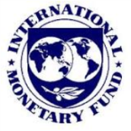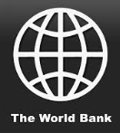
S\\TRTION FORM
Title (Mr. Mrs. etc.)
Last name
First name
Organisation or company
Email
Job title
Department/Division
Business phone
Address
City
State/Province
ZIP/Postal code
Country
Special requirements
Please email the completed form to sdmx2015@un.org by 31 July 2015
Contributors and presenters should register by 30 April 2015 at the latest

